Philippine Nurses Association of San Antonio (PMASA)
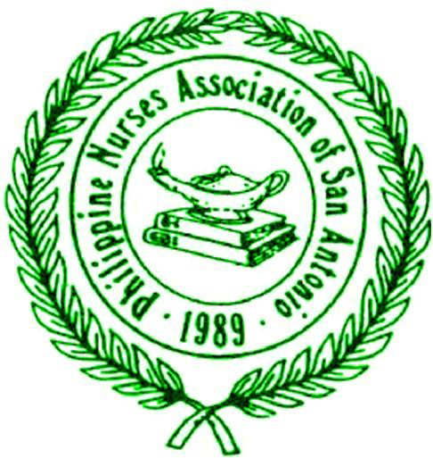
Excellence Award Nomination Form

Thank you for your support of the advancement and recognition of Filipino and Filipino-American nurses in your workplace. All nominees must be paid current members of PNASA. Any non-member can process their membership together with the nomination. All nominations should be submitted by November 30, 2016. Please complete this form for each nomination and e-mail to pnasa_ceu@yahoo.com .
All nominees will be recognized at the Excellence and Scholarship Gala on December 17, 2016 at the Hidalgo Ballroom, La Quinta Inn and Suites, 4431 Horizon Hill Blvd, San Antonio, TX 78229.
A. Person Nominating
Please provide details of the person nomination. Self-nominations are accepted.

Name/Degrees/Title: _Yvette Rodriguez, BSN, RN_________________________
Name of Institution: __University of TX Health Science Center at San Antonio__________________
Relationship to nominee (Select all that apply): Supervisor Colleague Friend Self Mentee
B. Nominee
1. Please circle a category of your nomination?
- Advance Practice b. Clinical (Staff) Nurse c. Community Service
- Nurse Administrator e. Nurse Educator f. Nurse Entrepreneur
- Nurse Informatics h. Nurse Researcher

2. Nominee Name/Degrees/Titles: M. Danet Lapiz-Bluhm, PhD, RN, MSCI
3. Nominee’s PNASA membership: Current paid member Will apply
(Please complete online membership application: https://www.surveymonkey.com/r/ZMP6JKG. Please contact pnasa_ceu@yahoo.com if you do not receive confirmation of receipt of membership application)

4. Describe briefly (200 words or less) the nominee’s achievements in the category chosen above to include leadership, teamwork, professionalism, achievements, etc.
Dr. Lapiz-Bluhm is an Associated Professor and the Founding Advisor of the International Nursing Students Association (INSA) at UTHSCSA. She has organized INSA to conduct several free health screenings yearly to >2,000 minorities through community collaborations (i.e., American Diabetes Association (ADA), American Kidney Fund, Latina Expo, Texas Folklife Festival, Asian Festival, Natalia Food Bank, Sto Nino Fiesta, Fiesta La Naval, Harris Middle School, Last Chance Ministries, and Edgewood Veterans, among others). She contributes to the green been campaign to support the Jimenez Thanksgiving Dinner, and donates for Paralyzed Veterans of America, Haven for Hope, St. Vincent de Paul Society and other refugee groups.
Internationally, Bluhm has conducted health screenings in the Philippines. She has been a resource speakers to various local, national and international events including the ”Balik Turo” program, where US nurses teach Philippine-based nurses/nursing students evidence-based practice and healthcare improvements. She is participating in a medical mission in Vigan in 01/2017. She has received multiple awards for her sustained community service and leadership from the Philippine Nurses Association of America Foundation, Philippine Women of America, and the UTHSCSA Student Government Association (c/o INSA). She takes great joy in serving and giving back to the community.

