Philippine Nurses Association of San Antonio (PMASA)
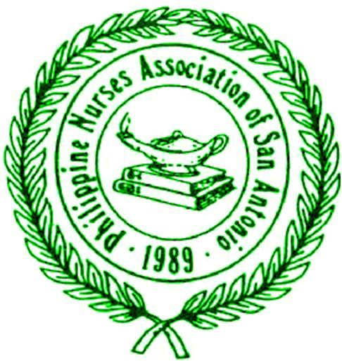
Excellence Award Nomination Form

Thank you for your support of the advancement and recognition of Filipino and Filipino-American nurses in your workplace. All nominees must be paid current members of PNASA. Any non-member can process their membership together with the nomination. All nominations should be submitted by November 30, 2016. Please complete this form for each nomination and e-mail to pnasa_ceu@yahoo.com .
All nominees will be recognized at the Excellence and Scholarship Gala on December 17, 2016 at the Hidalgo Ballroom, La Quinta Inn and Suites, 4431 Horizon Hill Blvd, San Antonio, TX 78229.
A. Person Nominating
Please provide details of the person nomination. Self-nominations are accepted.

Name/Degrees/Title: _FLoranie Ora BSN, RN, CCRN________________________
Name of Institution: __University of Hospital System__________________
Relationship to nominee (Select all that apply): Supervisor Colleague Friend Self
B. Nominee
1. Please circle a category of your nomination?
- Advance Practice b. Clinical (Staff) Nurse c. Community Service
- Nurse Administrator e. Nurse Educator f. Nurse Entrepreneur
- Nurse Informatics h. Nurse Researcher

2. Nominee Name/Degrees/Titles: Floranie F. Ora, BSN, RN, CCRN
3. Nominee’s PNASA membership: Current paid member Will apply
(Please complete online membership application: https://www.surveymonkey.com/r/ZMP6JKG. Please contact pnasa_ceu@yahoo.com if you do not receive confirmation of receipt of membership application)

4. Describe briefly (200 words or less) the nominee’s achievements in the category chosen above to include leadership, teamwork, professionalism, achievements, etc.
- Floranie Fruel Ora, BSN, RN III, CRRN, a graduate of Arellano University, currently
working at Reeves Rehab at the University Hospital, served as PNASA’s Executive Board
member since 2011, and Chair of the Committee on Ways and Means. She is a recognized
Management Development Academy Alumni of University Hospital of San Antonio Texas. In the
past, she worked in the Middle East, Abu Dhabi U.A.E., as a Deputy Charge Nurse where she
received an outstanding Achievement Award there and is now being nominated for Clinical Staff
Nursing Excellence Award.
Floranie is a compassionate and caring clinician, a forward thinker, and superb role
model. Dedicated to patient and family-centered care where she builds an open and trusting
relationship. Always looking for ways to improve care, with emphasis on integrating a positive
culture and innovation for patient safety and satisfaction. She exemplifies the best customer
service that is hard to surpass wherein she does not hesitate assuming dual role responsibilities of
being a nurse in charge and that of bedside nurse. Together with her calm and composed
leadership style, she was applauded and recognized by her supervisors, her patients, families, and
team members for her dedication and love for nursing.
Floranie is committed to providing patients and their families safe quality care. She has
been instrumental in achieving a high benchmark for pain control and satisfaction being the Pain
Resource Nurse of Reeves Rehab, taking a leading role in training co-workers on evidence based
pain management method at the Skill Fair to help improve quality outcome and patient
experience. At the same time working as a team leader in educational presentations for the Rehab
Nurses Workshops and Pain Awareness Week. And simultaneously coactive in motivational
Healing Art exhibits and poster making. She always strives for excellence and leadership. Her
participation was instrumental to staff education which provide better experience for the patients
and improvement of scores for Rehab unit. Her demeanor and work ethics have played an
Ms. Ora works at Reeves Rehab at the University Hospital System (UHS). She is a recognized Management Development Academy Alumni of UHS. A compassionate caring forward thinking clinician and a superb role model, she is committed to providing safe quality care. She has been instrumental in achieving a high benchmark for pain control and satisfaction as the Pain Resource Nurse by training co-workers on evidence-based pain management methods at the Skill Fair, Rehab Nurses Workshops and Pain Awareness Week while also helping with the motivational Healing Art poster exhibits. She strives for excellence and leadership. Her participation was instrumental to staff education to provide better experience for the patients and improve satisfaction scores. She played an integral role in 1st Magnet Site Survey and in presenting Cultural Diversity in the workplace. She has received numerous awards including 3-Time Silver Award, 7-Time above and beyond Recognition Award, 3-Time on the Spot Recognition, 3-Time Pin Recognition, 6-Time e button Recognition and certificate of appreciation for valuable contribution to UHS and to the PNASA. Of significance was her UHS 10th year anniversary award and recognition “for making a real and positive difference for the Health System and the people she serves”.

